**DAILY ONLINE ACTIVITIES SUMMARY**

|  |  |  |  |  |  |  |  |
| --- | --- | --- | --- | --- | --- | --- | --- |
| **Date:** | **03/06/2020** | | | | **Name:** | **Namratha C** | |
| **Sem & Sec** | **8th sem, A sec** | | | | **USN:** | **4AL16CS056** | |
| **Online Test Summary** | | | | | | | |
| **Subject** | | **No Test Conducted** | | | | | |
| **Max. Marks** | |  | | **Score** | |  | |
| **Certification Course Summary** | | | | | | | |
| **Course** | **Introduction to AWS Fargate** | | | | | | |
| **Certificate Provider** | | | **Aws training and certification** | **Duration** | | | **10mins** |
| **Coding Challenges** | | | | | | | |
| **Problem Statement: 1) Python program to check vowels and consonants.** | | | | | | | |
| **Status: Completed** | | | | | | | |
| **Uploaded the report in Github** | | | | **Yes** | | | |
| **If yes Repository name** | | | | **CODES (Namrathasonu)** | | | |
| **Uploaded the report in slack** | | | | **Yes** | | | |

Online Test Details: **No test conducted**

Certification Course Details:

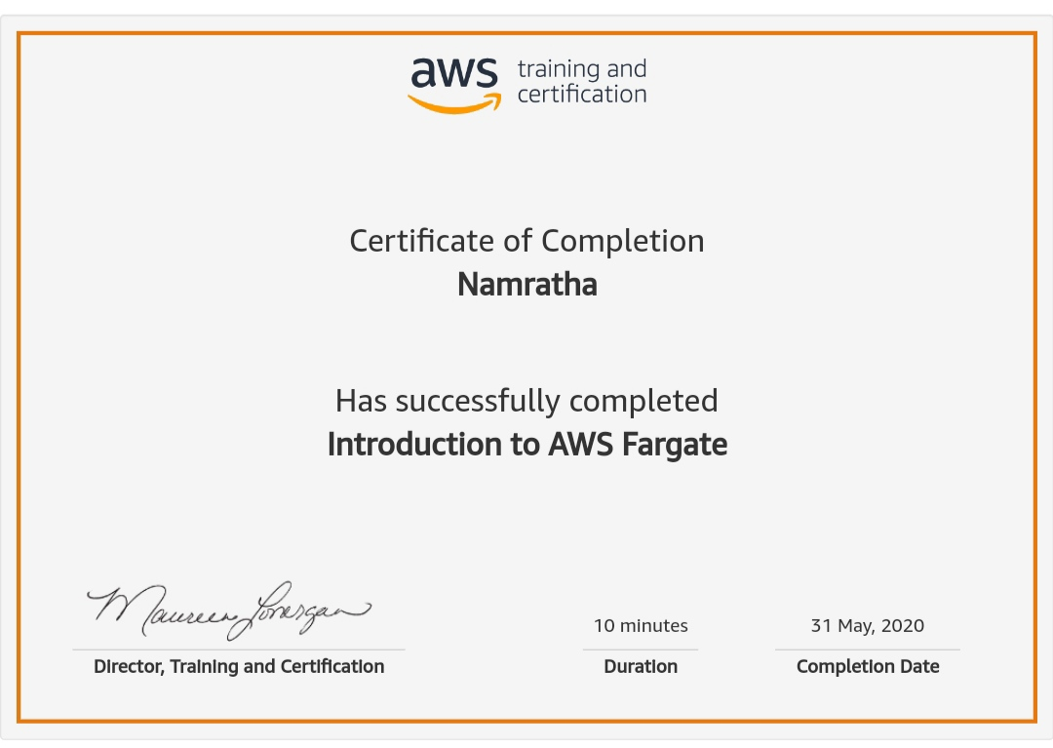

Coding Challenges Details:

1)

ch = input("Enter a character: ")

if(ch=='A' or ch=='a' or ch=='E' or ch =='e' or ch=='I'

or ch=='i' or ch=='O' or ch=='o' or ch=='U' or ch=='u'):

print(ch, "is a Vowel")

else:

print(ch, "is a Consonant")